Project phase-II

Solution Requirements (Functional & Non-functional)

|  |  |
| --- | --- |
| Name | JAGATHEESH B |
| Team ID | 912D6C8E79E54D694A04C468ED615272 |
| Project Name | Creating Email Campaign for Mail Chimp. |

**Customer Journey Maps:**

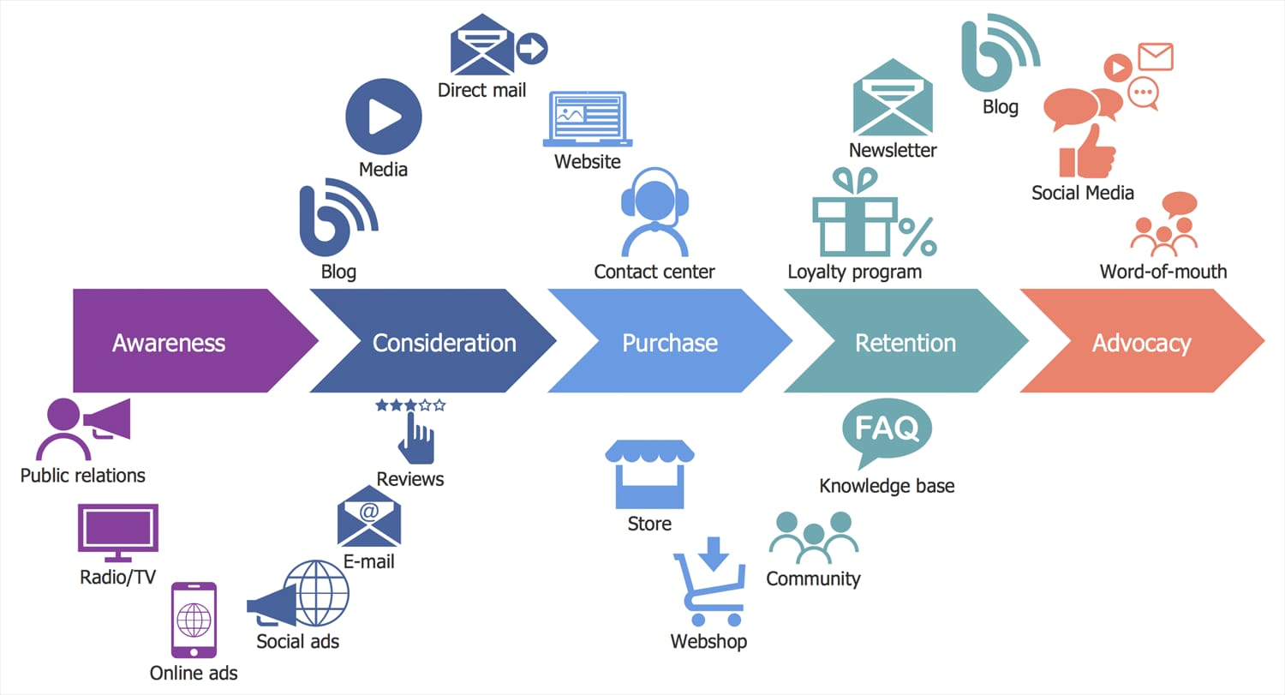

Functional Requirements:

|  |  |  |
| --- | --- | --- |
| FR NO. | Functional Requirements (Epic) | Sub Requirements (story/sub-task) |
| FR-1 | User Registration | When the user enter into the Email platform they need to register as a new user. For this the user must fill the needs by giving their credentials. Once they Sign In they enter into the website. |
| FR-2 | User confirmation | The confirmation of registration is done via OTP. By the code the registration process get completed. |
| FR-3 | Login | By the entering the credentials and password the user get login into the website. |
| FR-4 | Dashboard Function | After getting login the website dashboard will be available. The user can use their need the platform. Also they can see our advertisement in the same platform. The Ad will be send by the Email Chimp to the user. |
| FR-5 | User Notification | When the user see any revalent Ad of us, they will be notified by our company Ad. The website will Always show our Ad to the user in the email platform. |
| FR-6 | Administration | The website has an administration. It always check the activities of the users. It also maintain an performance of the website. |

**Technical Architecture:**

